Computing Consideration

* **Camera**

Previously, based on incorrect understanding of the project. Each conceptual design in the team will use a camera. And this plan is a costly and unnecessary choice. It is known in Technical Stream that ultrasonic sensors can completely replace cameras in detecting distance. So, team chose to stop using cameras and instead use sensors.

* **Ultrasonic sensors**

Ultrasonic sensors are necessary in the prototype because there is a requirement to cross the maze and not touch the wall in the problem statement. The main purpose of ultrasonic sensors is to detect the distance from walls in three directions. The computing members in the group need to design an ultrasonic sensor and Arduino uno circuit connection, as well as a program to detect obstacles in three directions of the robot, and finally display them in the serial monitor in digital or image form. This feature also has great application value. When robots perform remote rescue, they may encounter a loss of vision. Ultrasound can detect the surrounding environment without light.

**Technical Implementation**

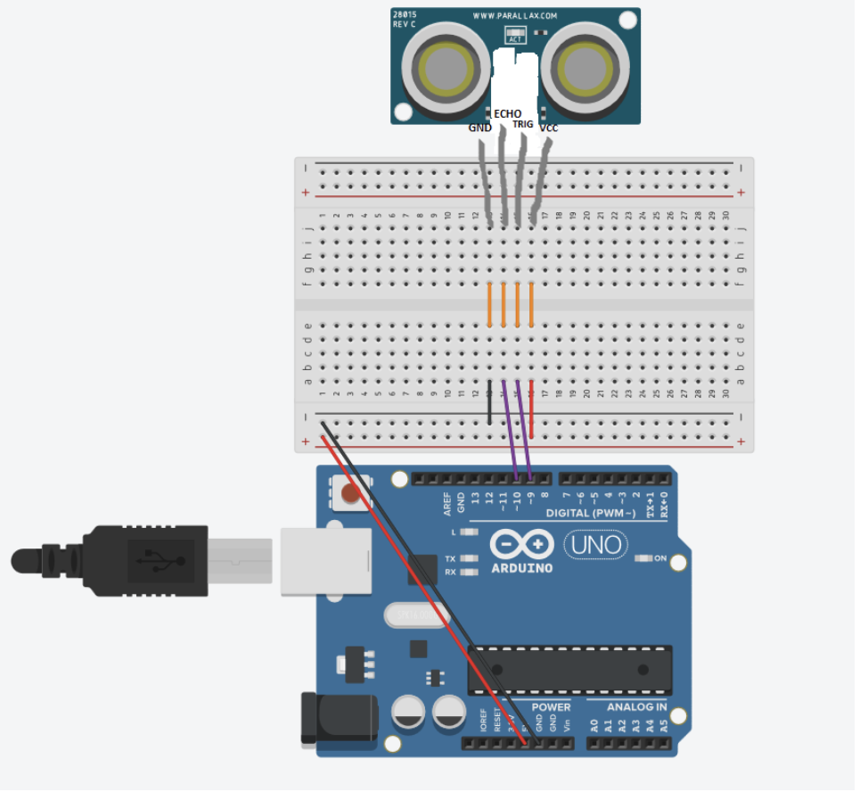

Figure 1 sensors connect on UNO by Zhaoyu

The ultrasonic sensor requires two PWM pins for connection. Next, three identical sensors need to be added.

* Wheels

Tank type tracks are used as a means of movement in both conceptual and prototype designs. In the group discussion, it was concluded that using tracks in the prototype design can better cross obstacles and make steering easier. What needs to be considered in the calculation is how to use programming to move the wheels on both sides and complete the steering after the circuit is connected.

**Wheel steering method**

To achieve a turn in a two wheeled vehicle, it is usually necessary to control the speed of the left and right wheels to cause the vehicle to change direction. Here are some programming methods for turning a two wheeled vehicle:

**Differential drive**: By controlling the speed difference between the left and right wheels, the vehicle can turn. When the left wheel rotates at a speed different from the right wheel, the vehicle will rotate around the centre point.

**Servo steering**: If your vehicle has front wheels or axles, you can use servo to control the direction of the front wheels. By turning the front wheels, the vehicle can change direction.

**Castor turn**: This is another method for vehicles to turn using casters or small wheels. By adjusting the direction of the casters, the driving direction of the vehicle can be changed.

The unanimous decision of the team is to use differential drive as the turning method for the robot. This method allows for the simplest operation and allows for a larger turning angle using relatively small space.

For example, when a robot needs to turn left, it can make a turn by increasing the speed of the left motor from 255 to -255, while the speed of the swimming motor remains at 255 to form a speed difference.

**The specific implementation is as follows**:

Connect two motors to the PWM pins on the uno board and then a motor driver is required to connect the motor. A motor driver can connect two motors.

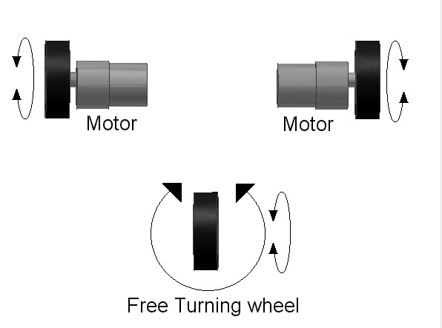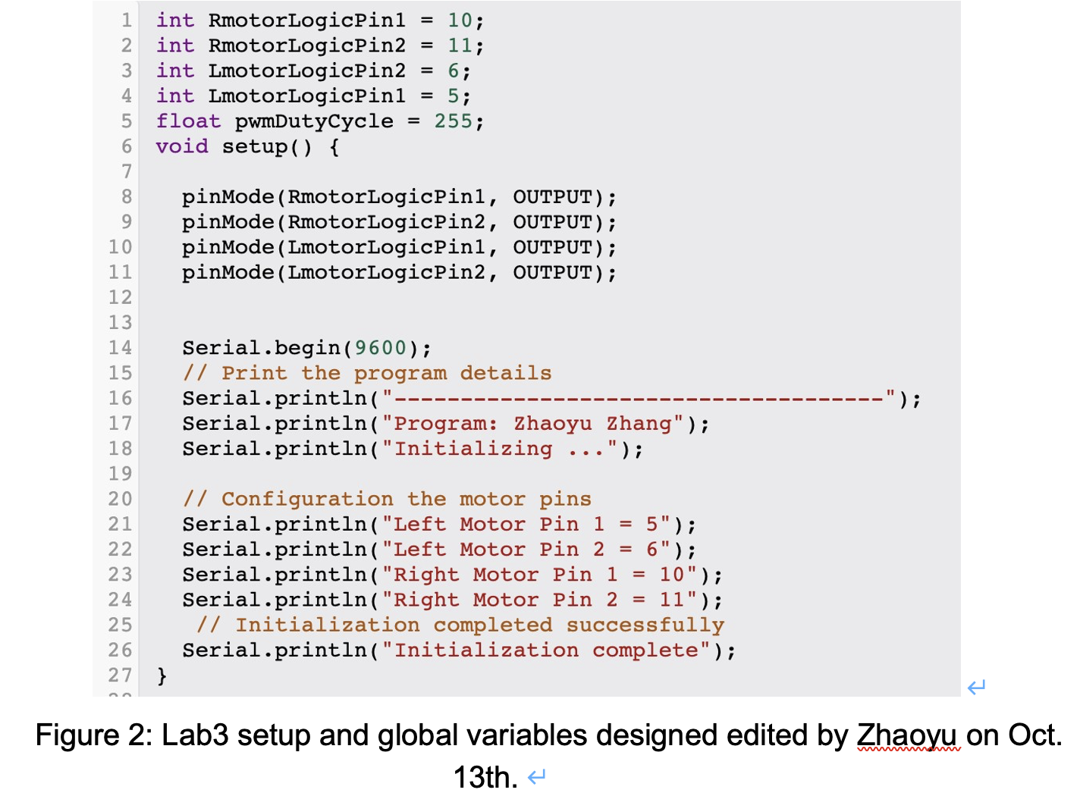

Next, we will use input operations to control the motion of the motor.

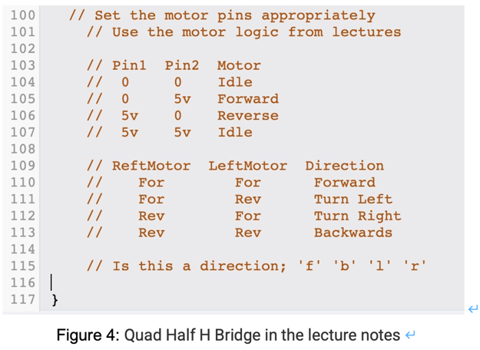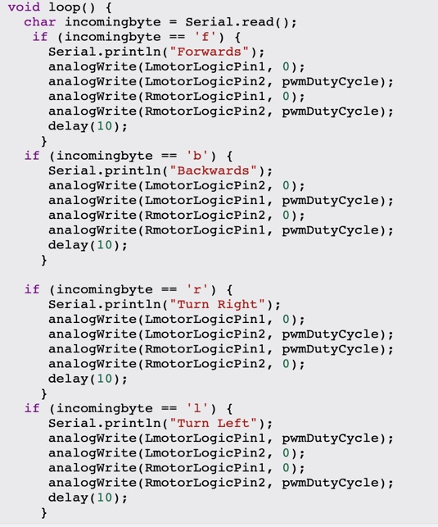

To verify the correctness and authenticity of this code. You can create a new circuit in Tinkercad to simulate this code. The results are as follows:

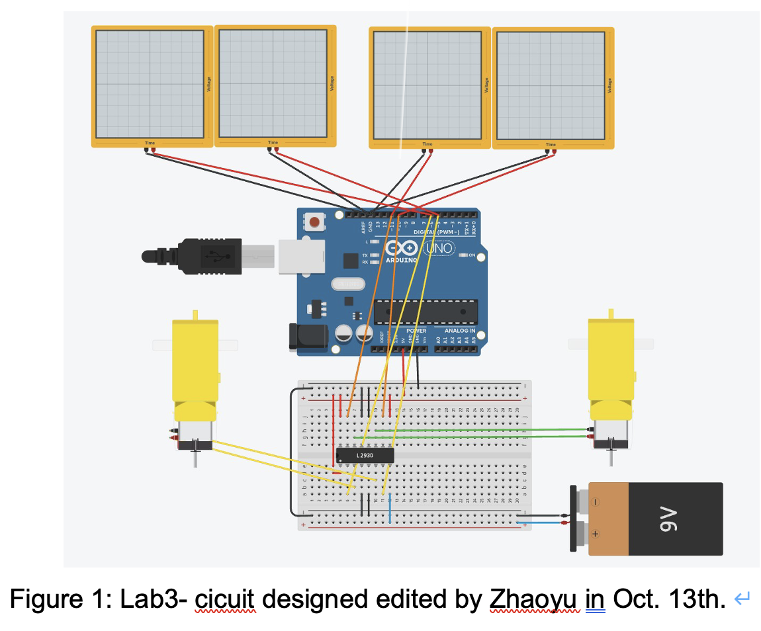

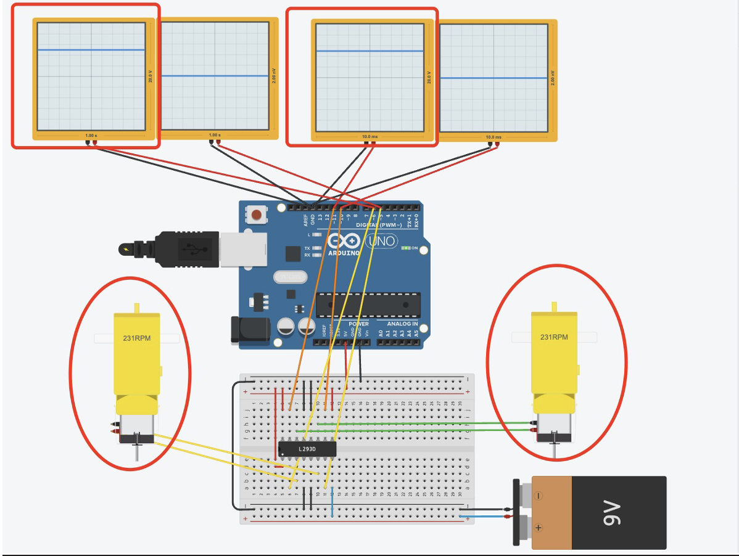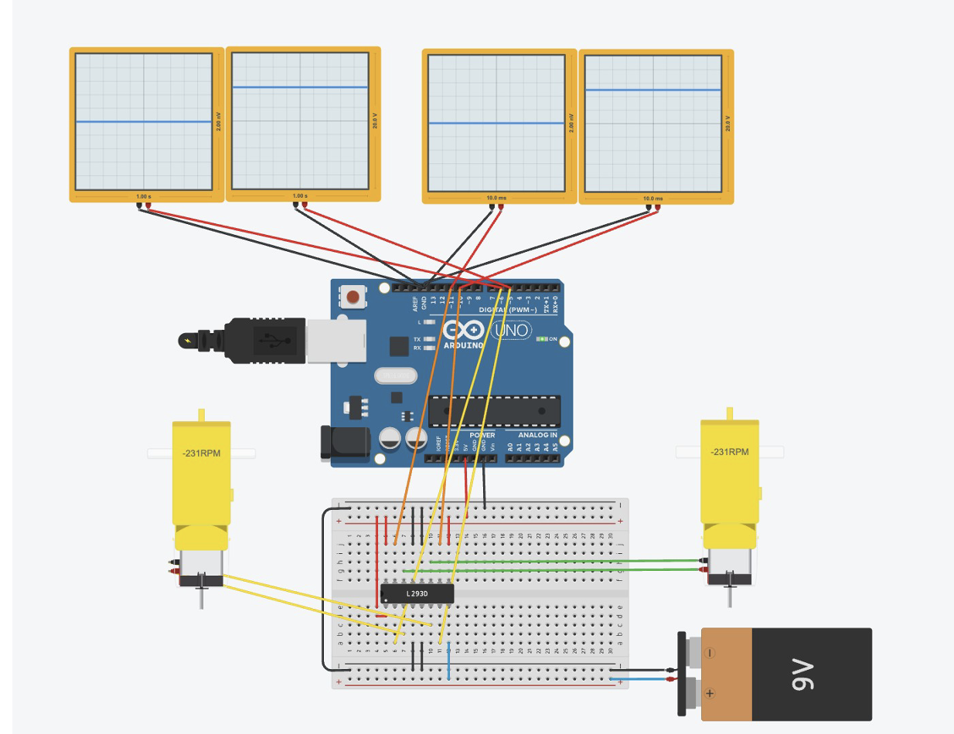

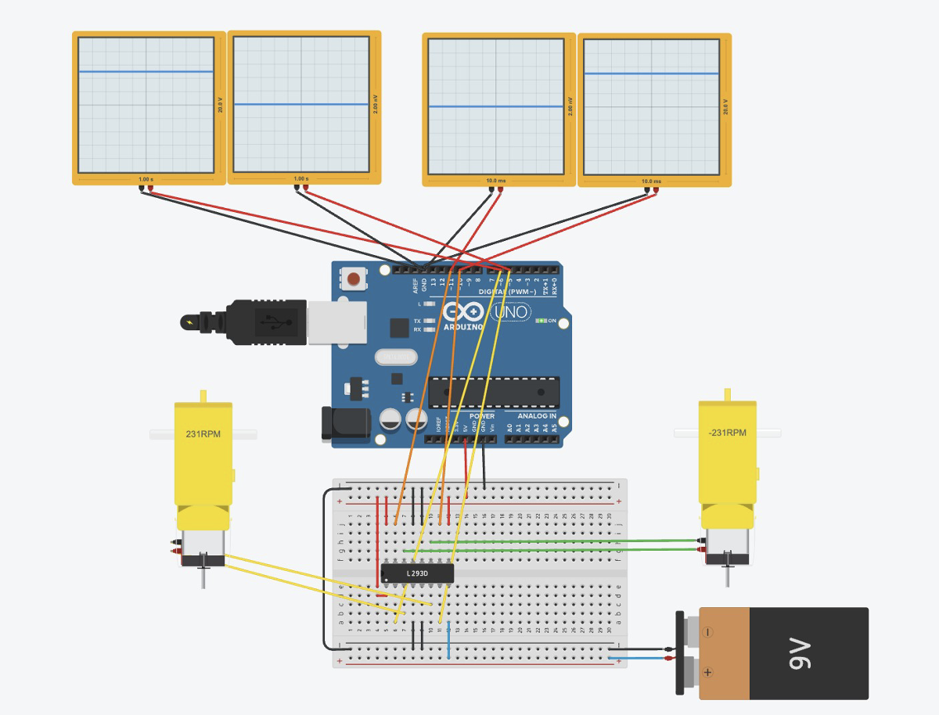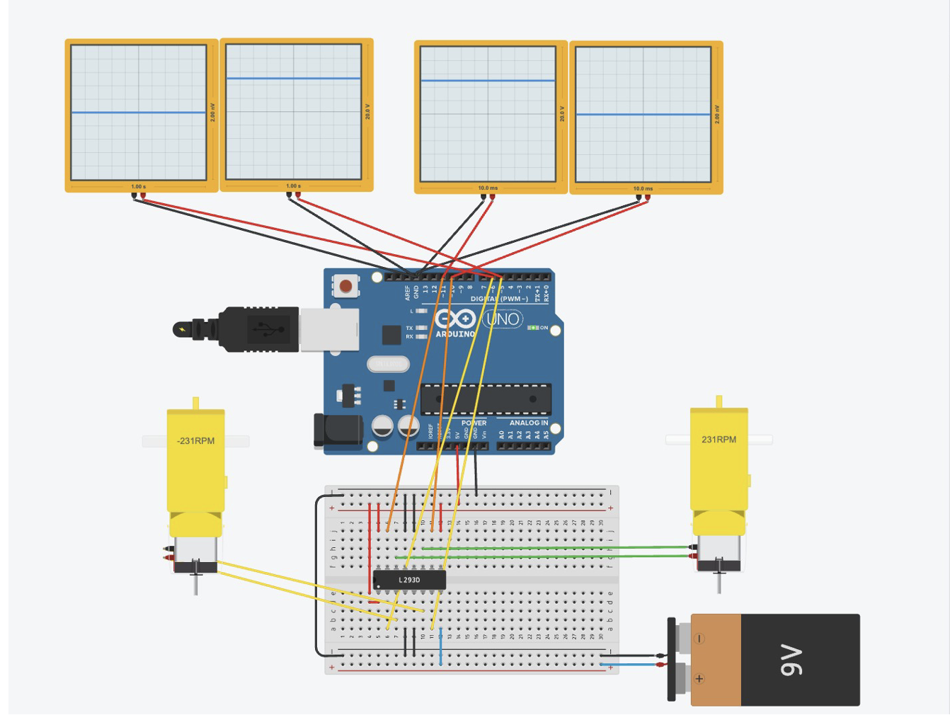

* Speed control

The control of speed can change the pulse period and voltage by changing the number of PWM cycles. Speed control is necessary to avoid damage from collisions with walls at specific points. And it can be operated more precisely during rescue.

